Part 1: Introduction

A drop in the number of engaged users of Yammer since August 1 has been observed:

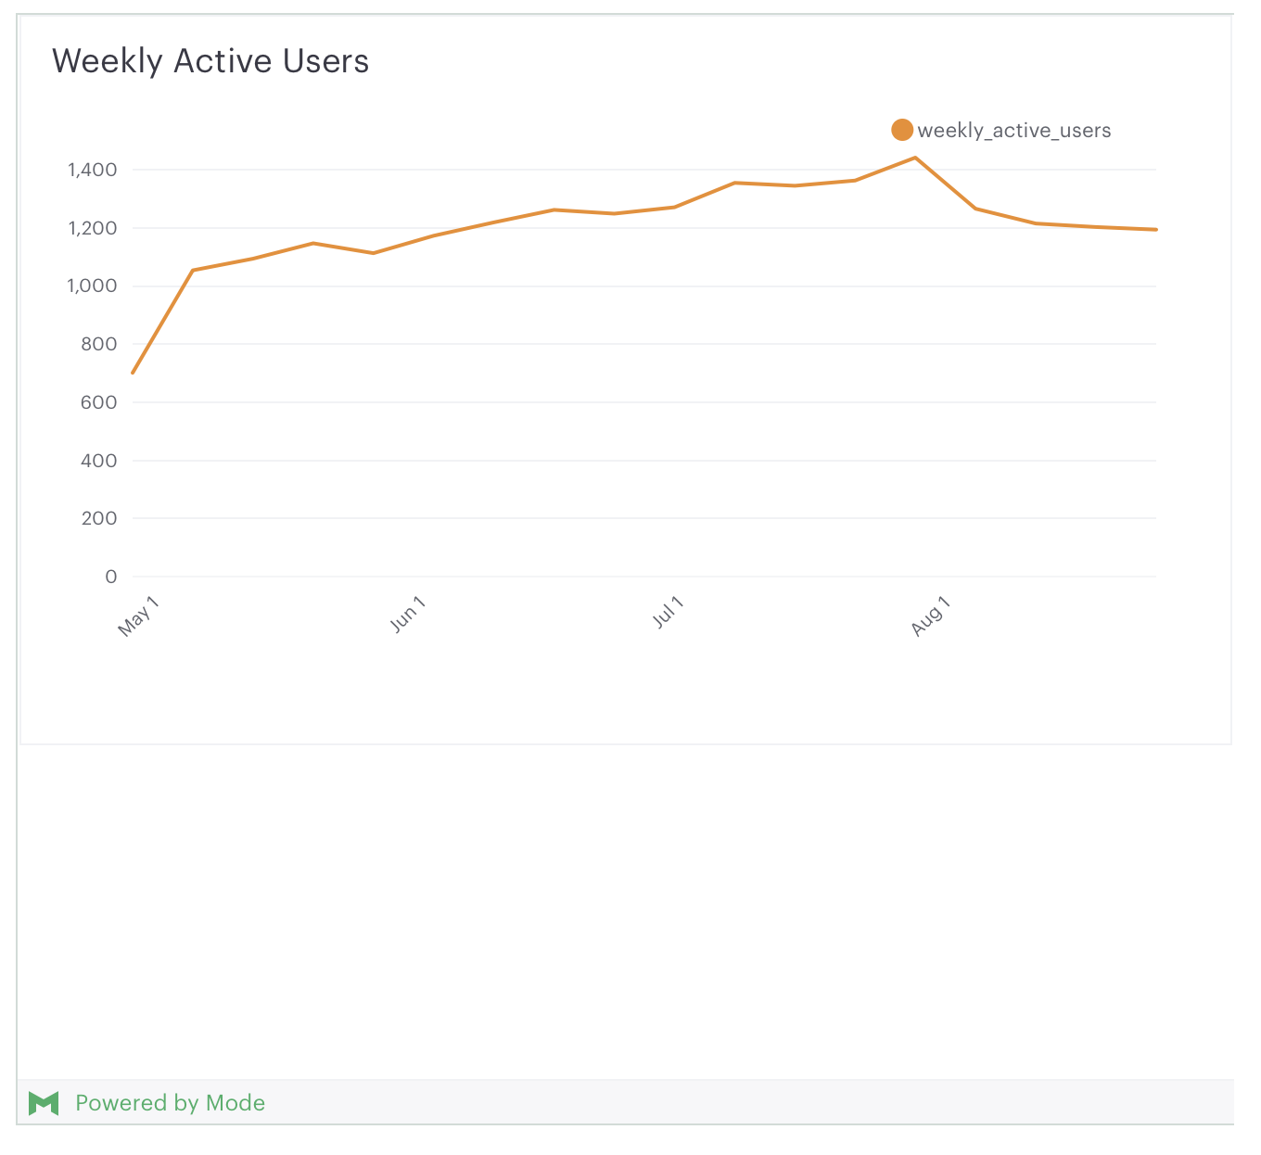

The task is to analyze available data to determine the possible reason for this drop.

Part 2: Possible Causes

The following are initial possible reasons for this drop in engagement:

1. Fewer people – more people are on vacation
2. Fewer people – more people are sick that week
3. Fewer people – layoffs occurred and there are fewer people in the company
4. Issue in a specific country
5. Issue on a specific platform
6. Equipment issues – people couldn’t log on
7. Less “interesting material” on Yammer
8. Issue in the code that tracks engagement levels
9. A marketing event caused a rise that has since subsided

Part 3: Analysis

(a) Verification of results

The first step is to confirm the drop seen in the graph. The following query was done:

SELECT drp.time_id,

       COUNT(DISTINCT e.user_id) AS weekly_active_users

  FROM benn.dimension_rollup_periods drp

  LEFT JOIN tutorial.yammer_events e

    ON e.occurred_at >= drp.pst_start

   AND e.occurred_at < drp.pst_end

   AND e.event_type = 'engagement'

   AND e.event_name = 'login'

 WHERE drp.period_id = 1007

   AND drp.time_id >= '2014-06-01'

   AND drp.time_id < '2014-09-01'

 GROUP BY 1

 ORDER BY 1

For the period on one week before and after 8/1, we get the following results:

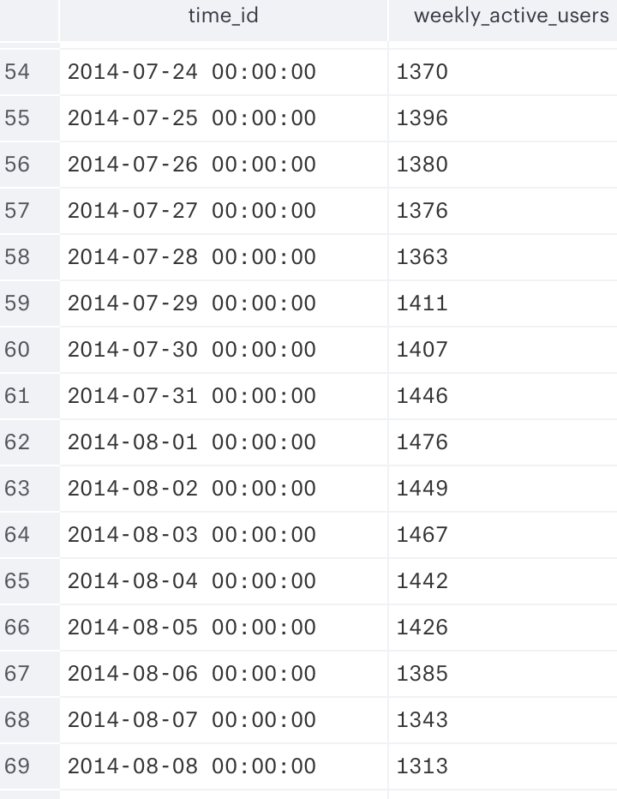

Comparing 8/1 to 8/8, one can see a drop from 1476 to 1313, or roughly 11%. This mirrors the results shown in the graph. In fact, if we extend the results to look at the 3 weeks after 8/1, one sees a a drop from 1476 to 1214, or roughly 18%.

(b) Check for # of users

Causes (1)-(3) all involve less engagement due to there being fewer users. To check this, we can look the total # of users in the same period. The query used was:

SELECT drp.time_id,

       COUNT(DISTINCT e.user_id) AS weekly_active_users

  FROM benn.dimension_rollup_periods drp

  LEFT JOIN tutorial.yammer_emails e

    ON e.occurred_at >= drp.pst_start

   AND e.occurred_at < drp.pst_end

 WHERE drp.period_id = 1007

   AND drp.time_id >= '2014-06-01'

   AND drp.time_id < '2014-09-01'

 GROUP BY 1

 ORDER BY 1

The result can be seen in the following table:

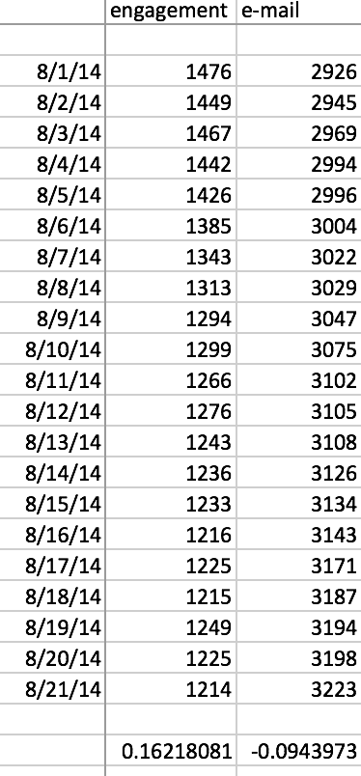

One can see that, while engagement falls from 1476 to 1214 from 8/1 to 8/21, the number of users of e-mail actually *increases* from 8/1 to 8/21, from 2926 to 3223. This rules out (1)-(3) as possible causes.

(c) Check if specific to a foreign language.

To check possibility (4), a query was done for English users. The reasoning is if it does not show a decrease, then we can look into the different languages and pinpoint the specific language(s) where there is an issue. To check on English, the language field in tutorial.yammer_users is used. The query used and the results are shown below:

SELECT drp.time_id,

       COUNT(DISTINCT e.user_id) AS weekly_active_users

  FROM benn.dimension_rollup_periods drp

  LEFT JOIN tutorial.yammer_events e

    ON e.occurred_at >= drp.pst_start

   AND e.occurred_at < drp.pst_end

   AND e.event_type = 'engagement'

   AND e.event_name = 'login'

   INNER JOIN tutorial.yammer_users u

      ON e.user_id = u.user_id

      AND u.language = 'english'

 WHERE drp.period_id = 1007

   AND drp.time_id >= '2014-06-01'

   AND drp.time_id < '2014-09-01'

 GROUP BY 1

 ORDER BY 1

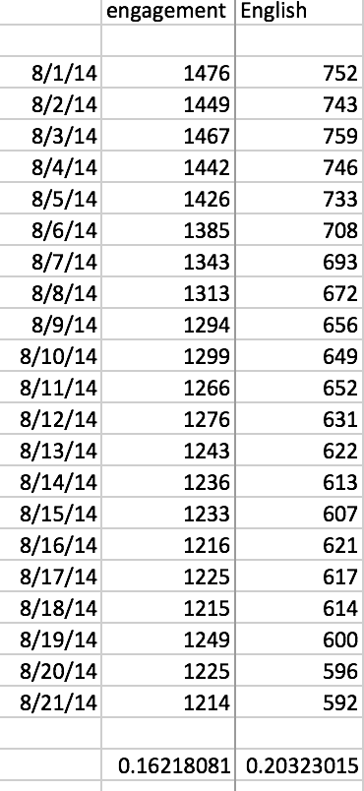

One can see a similar drop for English users from 8/1 to 8/21 (20% compared with the 16% for engagement). Based on this, one can see that the issue definitely involves English users and is *not* specific to a foreign language, ruling out cause (4).

(d) Check if specific to a platform

The next step was to look at the different platforms. The field “device” in “tutorial.yammer_events” was used. A sample query for “iphone” is used before. A similar query was used to find trends for Nexus, Samsung, iPad, Kindle, Dell, Macbook and Lenovo was done. The results can be seen in the table after the query:

SELECT drp.time_id,

       COUNT(DISTINCT e.user_id) AS weekly_active_users

  FROM benn.dimension_rollup_periods drp

  LEFT JOIN tutorial.yammer_events e

    ON e.occurred_at >= drp.pst_start

   AND e.occurred_at < drp.pst_end

   AND e.event_type = 'engagement'

   AND e.event_name = 'login'

   AND e.device ILIKE 'iphone%'

 WHERE drp.period_id = 1007

   AND drp.time_id >= '2014-08-01'

   AND drp.time_id < '2014-09-01'

 GROUP BY 1

 ORDER BY 1

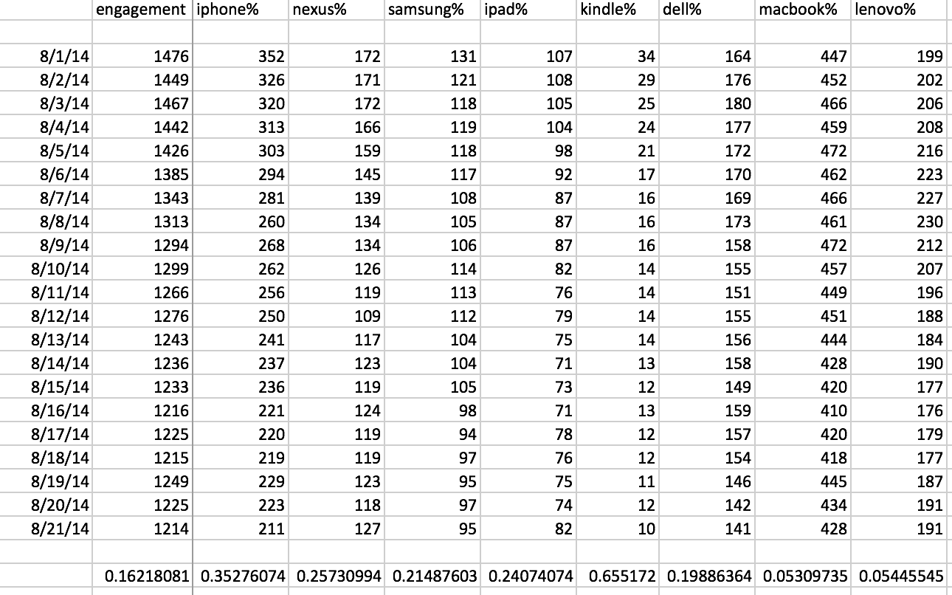

One can see a definite large drop in mobile devices (35% for the iPhone, 26% for the Nexus, 21% for the Samsung, 24% for the iPad), and a very small drop in 2 of the 3 desktops (5% for MacBook, 5% for Lenovo). Based on this, one can conclude that the issue seen is likely related to Mobile devices.

A word on the 2 columns showing outlier data – the Kindle and the Dell. For the Kindle, the number of values is relatively small (34, compared with > 100 for the other platforms), so this will be disregarded here. For the Dell desktop, while a ~20% drop is seen from 8/1 to 8/22, there is actually an increase from 8/1 to 8/8. That may indicate a latency somehow for the Dell, or perhaps the Dell numbers are indicative of a different issue. For the purposes of this investigation we will focus on mobile, since that is the strongest direction the data points to.

(e) Drill down into mobile numbers.

The next step was to pick a mobile platform (the iPhone was chosen, since that had the largest # of users), and see if the issue might be related to a specific country. The fields “device” and “location” in “tutorial.yammer_events” were used. An example of a query used (for the United States) is shown below with the results after that:

SELECT drp.time_id,

       COUNT(DISTINCT e.user_id) AS weekly_active_users

  FROM benn.dimension_rollup_periods drp

  LEFT JOIN tutorial.yammer_events e

    ON e.occurred_at >= drp.pst_start

   AND e.occurred_at < drp.pst_end

   AND e.event_type = 'engagement'

   AND e.event_name = 'login'

   AND e.device ILIKE 'iphone%'

   AND e.location = 'United States'

 WHERE drp.period_id = 1007

   AND drp.time_id >= '2014-07-01'

   AND drp.time_id < '2014-09-01'

 GROUP BY 1

 ORDER BY 1

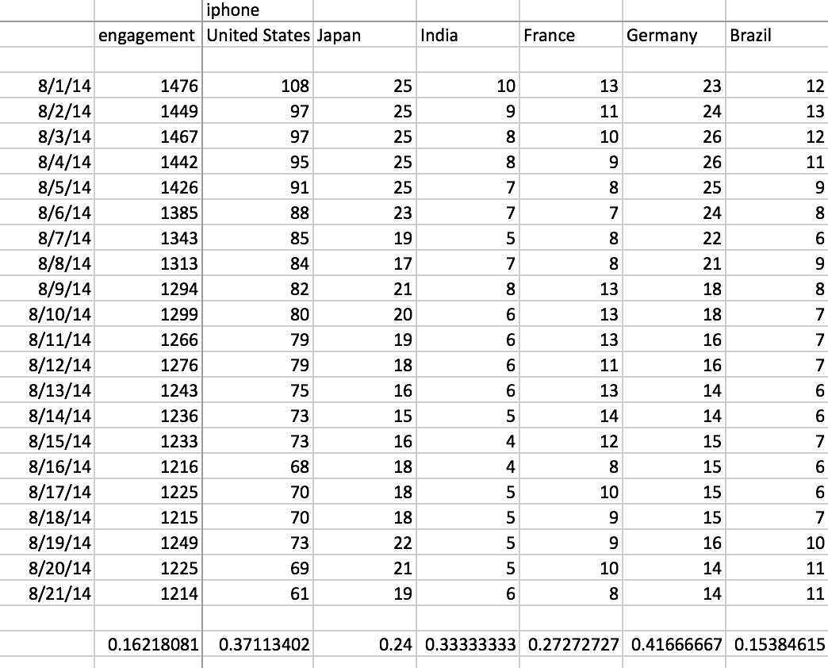

There isn’t a country that stands out as having an especially large drop compared to the others. Also, it is hard in general to derive significant meaning from the non-US countries, since the sample size is relatively small for them.

Part 3: Conclusions / Recommendations

Based on these results, our recommendation would be to focus on the deployments of the mobile software – was there a deployment on 8/1? If so, looking at the differences might point to the reasons for the drop in engagement seen. The data also seem to indicate this is not necessarily specific to a certain device (iPhone, Nexus, Samsung all show drops) and also not necessarily specific to a certain country.

A brief word on the other possibilities mentioned at the beginning of this report. The attendance results conclusively rule out possibilities (1)-(3) and (6). The trend seen in the US also rules out (4). Possibilities (7)-(9) would be difficult to measure based on the data that exists. This leaves possibility (5) – which leads to the mobile results this report recommends looking into.